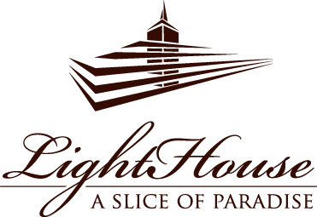

BANQUET OFFER

95 EUR
per person

MATJES HERRING

APPETIZER

VEAL ROASTBEEF
with potato gratin, greens curd, pickled onions and mustard seeds

STRACCIATELLA CHEESE
with sweet tomatoes, pesto, hazelnuts, fresh basil and balsamic sauce

SHRIMP AND SCALLOP CARPACCIO
with capers, shallots, dried tomatoes, quinoa flakes and apple sauce

GREEK SALAD
with grilled peppers, cherry tomatoes, romesco sauce and feta cheese

with dried tomatoes, ricotta cheese, mushrooms, peppers and honey-mustard sauce

DUCK TERRINE
with asparagus salsa, herbs, garlic confit and truffle sauce

TUNA TARTARE
with avocado, mango, egg gel, toast, pickled mustard seeds, orange segments and whitefish caviar

BEEF CARPACCIO
with marinated honey mushrooms, Cipriani sauce, parmesan and arugula

HOT APPETIZER

GNOCHI WITH SHRIMP
with mushrooms, asparagus and cream sauce

MAIN DISH

STURGEON FILLET
with bulgur, porcini mushrooms, melted cheese and white wine sauce

or

OCTOPUS
with black hummus, asparagus, paprika and chimichurri sauce

or

ENTRECOTE
with parsnip and coffee puree, grilled vegetables and red wine sauce

or

DUCK BREAST
with onion marmalade, root vegetable pearls, red wine and apple sauce

HOME-BAKED BUNS, HUMMUS, OLIVES

