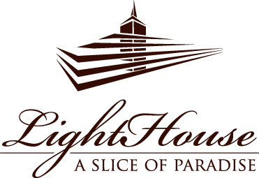

BANQUET OFFER

75 EUR

per person

MATJES HERRING

APPETIZER

GREEK SALAD

with potato gratin, greens curd, pickled onions and mustard seeds

STRAСCIATELLA CHEESE
with sweet field tomatoes, pesto, hazelnuts, fresh basil and balsamic sauce

LIGHTLY SALTED SALMON
with fresh cheese and herbs, and potato and zucchini pancakes

with grilled peppers, cherry tomatoes, romesco sauce and feta cheese

VEAL ROAST BEEF
with dried tomatoes, ricotta cheese, mushrooms, peppers and honey-mustard sauce

DUCK TERRINE
with asparagus salsa, herbs, garlic confit and truffle sauce

MAIN DISH

FLANK STEAK
with new potatoes and mushroom sauce

or

CORN-FED CHICKEN BREAST
with parsnip puree, grilled vegetables and chimichurri sauce

or

WHITE FISH FILLET
with vegetable ratatouille roll, aioli and herb mayonnaise

HOME-BAKED BUNS, HUMMUS, OLIVES

